Application Project Report

Marketing Analytics

Optimizing Telecom Churn Prevention: A Data-Driven Marketing Strategy

Introduction
This report presents a comprehensive analysis of customer churn patterns for Maven Communications' Q2 2022 customer base. Using advanced predictive modeling and interactive visualization techniques, we identified key drivers of customer attrition and developed targeted marketing interventions to improve retention rates.
Key Findings:
- High-risk customers are characterized by month-to-month contracts, high monthly charges, and minimal add-on services.
- Fiber Optic users and senior customers (60+) represent the highest churn segments.
- Payment method and contract type are among the strongest predictors of churn behavior.
- Risk segmentation reveals 20% of customers account for 75.7% average churn probability.
- Targeted interventions on contract upgrades, service improvements, and digital payments can significantly reduce churn.

Research objective
The objectives of our research project are outlined below:
- To build interactive Tableau and Power BI dashboards that provide clear visual insights into telecommunication customer behavior and churn patterns, enabling leadership to take strategic data-driven decisions.
- To identify key factors that drive customers to churn through Exploratory Data Analysis (EDA) and predictive analysis.
- To create Machine Learning based classification model to segment customers into High, Medium , and Low risk groups for targeted interventions.
- To evaluate the strengths, challenges, and practical applications of both Tableau and Power BI in a telecommunications context .
- To translate analytical findings into specific measurable marketing strategies that reduce churn and improve customer satisfaction .

Research design
Data Preparation
- Resolve missing and inconsistent data through data integrity checks, data cleaning, and imputation.
- Standardize data types and create derived variables for analysis such as churn rate, grouped categories, service bundles, and age groups.
Exploratory Data Analysis
- Conduct exploratory data analysis of churn pattern across demographic, behavioral, and financial segments
- Create visualizations to derive meaningful insights
- Derive meaningful relationship between churn and other factors
Predictive Modelling
- Evaluate classification modeling techniques such as Logistic Regression to identify a strong model for our project
- Employ the model in SAS Viya to identify strong churn patterns and what variables drive the churn
- Applied stepwise feature selection to identify optimal predictors while avoiding overfitting
Risk Segmentation
- Use quantile-based bucketing to segment customers by predicted churn probability
- Create balanced risk tiers: Low Risk (40%), Medium Risk (40%), High Risk (20%)
- Profile each segment by demographic, behavioral, and financial characteristics
Dashboard Development
- Import cleaned data into Power BI and Tableau
- Created KPI cards, trend visualizations, and interactive filters
- Build dashboards to support real-time monitoring and decision-making

Research Analysis
Results of Logistic Regression Stepwise Selection:
- Identified 13 optimal predictors through automated selection
- Achieved a 37% improvement in model fit (SBC reduction from 5,712.93 to 3,615.32)
Strong Positive churn drivers:
- High Monthly Charges: Customers with higher monthly charges significantly are more likely to churn or switch their network
- Month-to-Month Contracts: Contract type is the second-strongest predictor, with a churn rate of more than 40%. Customers with only monthly contracts instead of yearly are more likely to churn.
- Absence of Add-On Services: Customers with no Phone Service, no Premium Tech Support, no Online Security, and No Online Backup have a higher churn risk
Strong Negative (Protective) Factors:
- Longer Tenure: Each month of tenure reduces churn probability; customers with 40+ months tenure have <5% churn rate
- Credit Card or Bank Withdrawal Payments: Automatic payment methods reduce churn compared to mailed checks
- Paperless Billing: Adoption of digital billing indicates higher engagement and loyalty
Most Influential Predictors:
- Monthly Charge
- Contract Type
- Tenure
- Payment Method
- Add-On Service Usage
Risk Segmentation Profiles:
- Using predicted churn probabilities, customers were segmented into three actionable risk tiers:
Risk Segment | Customer Count | Avg Churn Probability | Avg Tenure | Avg Monthly Charge
Low Risk | 2,817 | 1.4% | 47 months | $56.77
Medium Risk | 2,817 | 26.8% | 27 months | $65.28
High Risk | 1,409 | 75.7% | 14 months | $80.35

Key Insights
- High-risk customers are characterized by lower tenure (14 months).
- Higher monthly charges ($80.35), and less stable engagement patterns. This profile represents only 20% of the customer base but accounts for most churn risk.
Critical Churn Segments Identified
- Month-to-Month Contract Holders: >40% churn rate; largest addressable segment
- Fiber Optic Users: 1,236 customers with highest churn; service satisfaction concerns
- Senior Customers (60+): Highest churn among age groups; need simplified, senior-friendly plans
- Mailed Check & Bank Withdrawal Users: 40% churn; payment friction indicates lower engagement
- Single-Line Customers: Lower perceived value vs. multi-line bundle customers

Research Solution
Based on analytical findings, we propose five high-impact marketing strategies:
1. Month-to-Month Contract Reduction Campaign
Problem: 40%+ churn rate for month-to-month customers due to commitment issues
Solution:
- Launch contract upgrade campaign targeting month-to-month customers with 12-18 months tenure
- Offer 10-15% discount for annual contracts; emphasize stability and predictability
- Send targeted win-back emails to churn month-to-month customers with special retention offers
- Create loyalty reward program (bill credits, service upgrades) for contract upgrades
Expected Impact: Reduce month-to-month churn by 20-25% and an increase in average contract length
2. Fiber Optic Service
Problem: 1,236 Fiber Optic customers churning at highest rates due to service satisfaction issues
Solution:
- Conduct customer satisfaction survey to identify specific pain points (speed, reliability, customer service)
- Develop loyalty packages including priority support, speed upgrades, and exclusive features
- Create Fiber Optic subscriber community with exclusive content and technical resources
- Implement proactive outreach for service issues before customers contact support
Expected Impact: Reduce Fiber Optic segment churn by 15-20%
3. Senior-Friendly Plans & Programs
Problem: Senior customers (60+) experience high churn due to complexity and cost barriers
Solution:
- Design simplified rate plans with transparent pricing and fewer add-on options
- Offer senior discounts (5-10%) on essential services and bundles
- Develop dedicated senior support line with extended hours
- Partner with senior centers and organizations for co-marketing and outreach
Expected Impact: Reduce senior segment churn by 25-30% and increase lifetime value

4. Digital Payment Adoption Program
Problem: Mailed check and bank withdrawal users churn at around 40% due to payment friction indicating lower engagement
Solution:
- Incentivize auto-pay adoption with $3-5 monthly discount
- Simplify auto-pay onboarding to single-click enrollment
- Send SMS reminders for upcoming payments to increase engagement
- Highlight security and convenience benefits of digital payments
Expected Impact: Convert 30% of mailed check users to auto-pay and reduce payment-related churn by 15%
5. Multi-Line & Bundle Expansion Strategy
Problem: Single-line customers have higher churn; multi-line customers demonstrate greater loyalty
Solution:
- Create household bundle packages that combine internet, phone, and streaming at discount
- Target single-line customers with promotional offers to add services
- Highlight savings and convenience of unified billing
- Develop family plans with special features for multi-device households
Expected Impact: Increase multi-line penetration by 20% and reduce single-line customer churn by 15%

Research Conclusion
Maven Communications' churn prevention initiative successfully combines predictive modeling, customer segmentation, and interactive visualization to transform data into actionable marketing strategy. Key accomplishments include:
- Predictive Model: Logistic regression model identifies 13 key churn drivers with 37% improved fit vs. baseline
- Customer Segmentation: Risk-based segmentation enables precise targeting of high-churn groups
- Actionable Insights: Five data-driven marketing strategies directly address identified churn drivers
- Operational Tools: Interactive dashboards provide real-time visibility for ongoing monitoring and decision-making

Appendix A – Selection Summary of Logistic regression Model
Step | Effect Entered | Effect Removed | Number of Effects | SBC | Optimal SBC
0 | Intercept |  | 1 | 5,712.93 | 0
1 | Contract |  | 2 | 4,729.24 | 0
2 | NumberofReferrals |  | 3 | 4,245.74 | 0
3 | InternetType |  | 4 | 3,944.90 | 0
4 | TenureinMonths |  | 5 | 3,849.09 | 0
5 | NumberofDependents |  | 6 | 3,779.51 | 0
6 | PaymentMethod |  | 7 | 3,716.02 | 0
7 | TotalCharges |  | 8 | 3,699.06 | 0
8 | OnlineSecurity |  | 9 | 3,675.02 | 0
9 | Age |  | 10 | 3,666.41 | 0
10 | PaperlessBilling |  | 11 | 3,661.07 | 0
11 | PremiumTechSupport |  | 12 | 3,656.83 | 0
12 | MonthlyCharge |  | 13 | 3,654.84 | 0
13 |  | InternetType | 12 | 3,644.44 | 0
14 | PhoneService |  | 13 | 3,620.68 | 0
15 | OnlineBackup |  | 14 | 3,617.34 | 0
16 | Offer |  | 15 | 3,616.96 | 0
17 |  | TotalCharges | 14 | 3,615.32 | 1

Appendix B: Power BI Dashboard
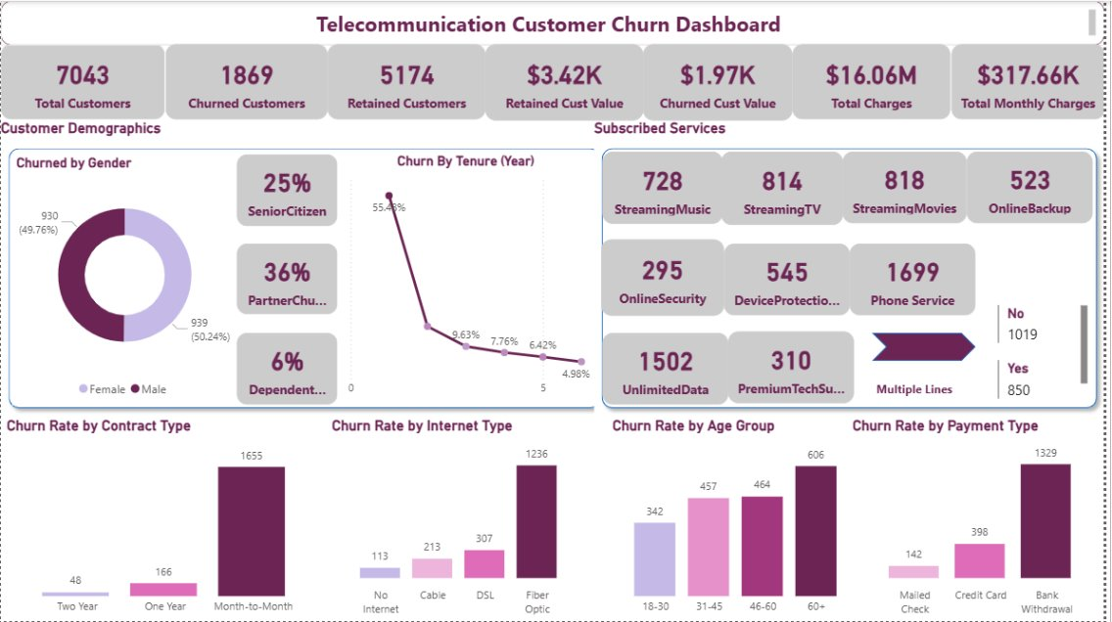

Appendix B: Tableau Dashboard
